**List ( unordered list and ordered list )**

* Create a web page to display your personal details in the given format:

• ID: xxxx

• Name: xxxx

• Group No: xxxx

• Course Name: xxxx

• E-mail: xxxx

The main heading of the page should be "My Profile" below which the above mentioned details should be displayed. Also the left-hand side details like ID, Name, Group, etc., should be displayed in bold.

<!DOCTYPE html>

<html lang="en">

    <head>

        <meta charset="UTF-8">

        <title>My Profile</title>

    </head>

    <body>

        <h1>My Profile</h1>

        <div class="details">

            <p><strong>ID:</strong>

                <span id="id">xxxx</span></p>

            <p><strong>Name:</strong>

                <span id="name">xxxx</span></p>

            <p>

                <strong>Group No:</strong>

                <span id="group_no">xxxx</span>

            </p>

            <p><strong>Course Name:</strong>

<span id="course_name">xxxx</span></p>

            <p><strong>E-mail:</strong>

                <span id="email">xxxx</span></p>

        </div>

    </body>

</html>

**Strong element:**

يُستخدم لتأكيد النص وجعله أكثر وضوحًا و يُعرض عادةً **بالخط العريض**

**Span element :**

يُستخدم ل**تجميع جزء من النص** دون التأثير على تدفقه و يُستخدم لتطبيق الأنماط على أجزاء محددة من النص، مثل التمييز والعلامات العليا.

**Dev element:**

وهو عنصر لتجميع المحتوى على صفحة الويب ويستخدم لإنشاء أقسام مميزة داخل الصفحة.

**list-order**

مثال :

**Create a web page display this :**

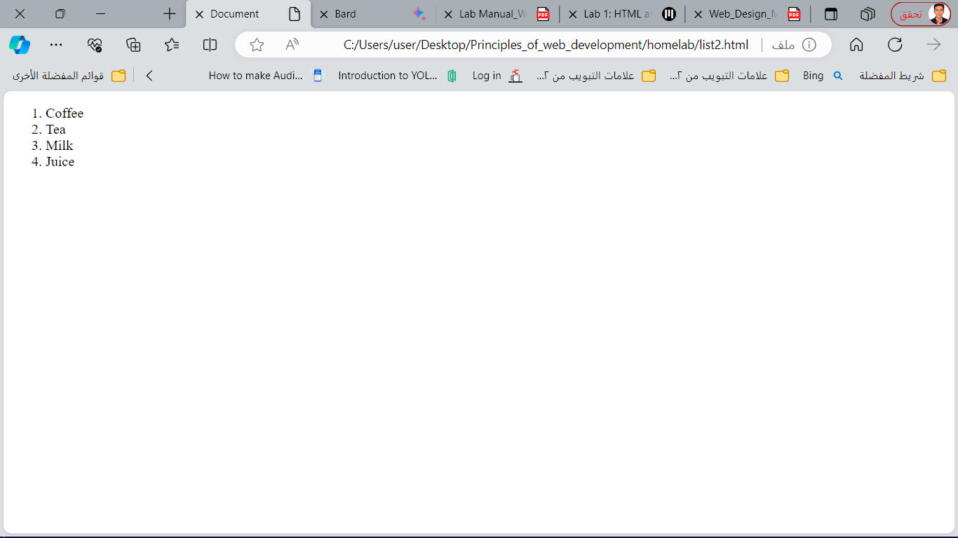

<ol style="list-order: lower-alpha;">

        <li>Coffee</li>

        <li>Tea</li>

        <li>Milk</li>

        <li>Juice</li>

      </ol>

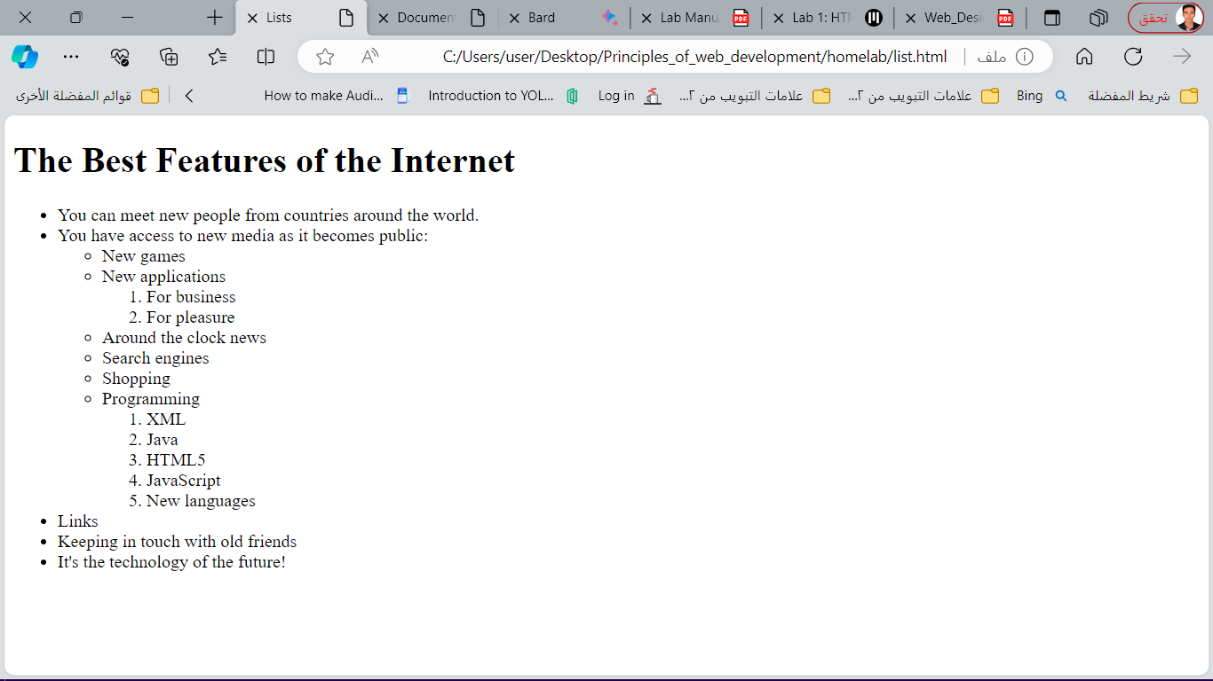Write code to DESIGN THIS WEB BAGE :

<body>

      <h1>The Best Features of the Internet</h1>

      <ul>

         <li>You can meet new people from countries around

            the world.</li>

         <li>

            You have access to new media as it becomes public:

*<!-- this starts a nested unordered list, which uses a -->*

*<!-- different bullet. The list ends when you -->*

*<!-- close the <ul> tag. -->*

            <ul>

               <li>New games</li>

               <li>New applications

                  <ol>

                     <li>For business</li>

                     <li>For pleasure</li>

                  </ol>

               </li>

   <li>Around the clock news</li>

               <li>Search engines</li>

               <li>Shopping</li>

               <li>Programming

                  <ol>

                     <li>XML</li>

                     <li>Java</li>

                     <li>HTML5</li>

                     <li>JavaScript</li>

                     <li>New languages</li>

                  </ol>

               </li>

            </ul>

         </li>

         <li>Links</li>

         <li>Keeping in touch with old friends</li>

         <li>It's the technology of the future!</li>

      </ul>

   </body>

TABLES

Create a web page to display your personal details in a table.

<!DOCTYPE html>

<html>

<head>

<title> Table Exercise </title>

</head>

<body>

<h2>Students Information</h2>

<table style="width:50%">

<tr>

<th>Student ID</th>

<th>Student Name</th>

<th>Email</th>

</tr>

<tr>

<td>123456789</td>

<td>Abdullah</td>

<td>abdullah@gmail.com</td>

</tr>

<tr>

<td>234567891</td>

<td>Ahmad</td>

<td>soude@google.com</td>

</tr>

<tr>

<td>345678912</td>

<td>Ali</td>

<td>ali@gmail.com</td>

</tr>

Page 5 of 37

</table>

</body>

</html>

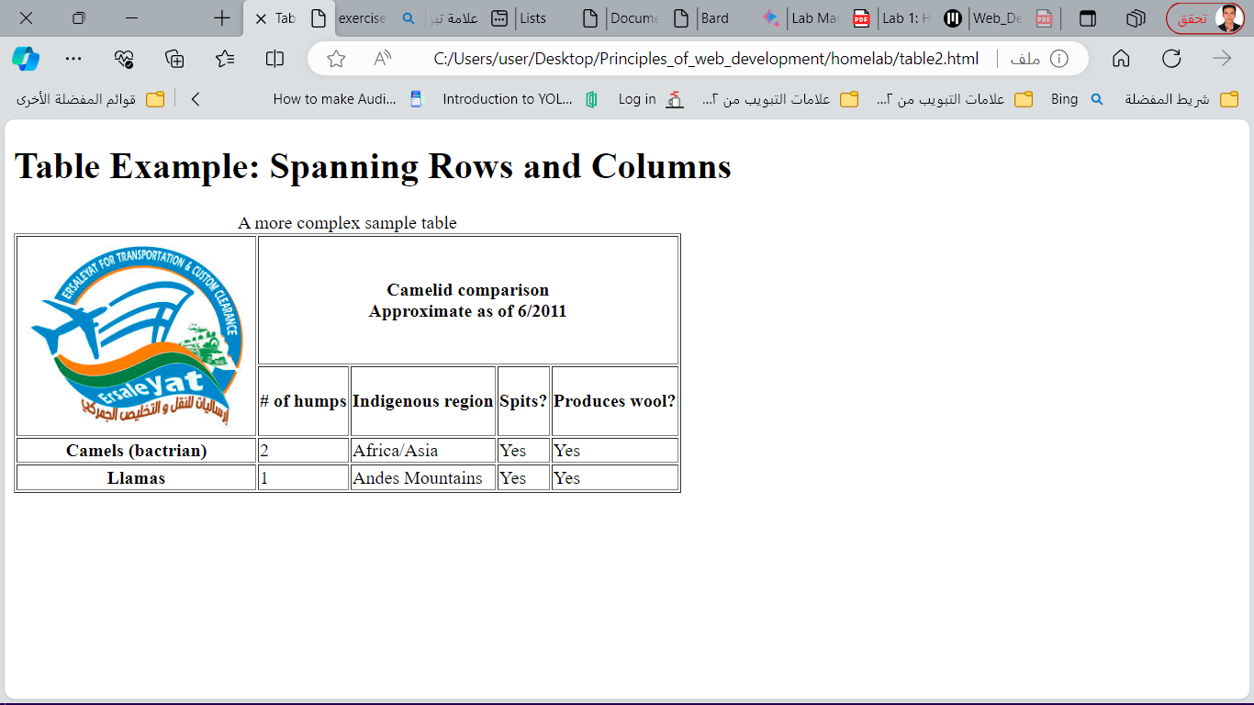Write HTML code to create the following webpage:

Code

<!DOCTYPE html>

*<!-- Fig. 2.13: table2.html -->*

*<!-- Complex HTML5 table. -->*

<html>

   <head>

      <meta charset = "utf-8">

      <title>Tables</title>

   </head>

   <body>

      <h1>Table Example: Spanning Rows and Columns</h1>

      <table border = "1">

         <caption>A more complex sample table</caption>

         <thead>

*<!-- rowspans and colspans merge the specified -->*

*<!-- number of cells vertically or horizontally -->*

            <tr>

*<!-- merge two rows -->*

               <th rowspan = "2">

                  <img src = "../image  lab/PAG1.jpg" width = "205"

                     height = "167" alt = "Picture of a one-hcamel">

               </th>

*<!-- merge four columns -->*

               <th colspan = "4">

                  <strong>Camelid comparison</strong><br>

                  Approximate as of 6/2011

               </th>

            </tr>

            <tr>

               <th># of humps</th>

               <th>Indigenous region</th>

               <th>Spits?</th>

               <th>Produces wool?</th>

            </tr>

         </thead>

         <tbody>

            <tr>

               <th>Camels (bactrian)</th>

               <td>2</td>

               <td>Africa/Asia</td>

               <td>Yes</td>

               <td>Yes</td>

            </tr>

            <tr>

               <th>Llamas</th>

               <td>1</td>

               <td>Andes Mountains</td>

               <td>Yes</td>

               <td>Yes</td>

            </tr>

         </tbody>

      </table>

   </body>

</html>

Forms

* 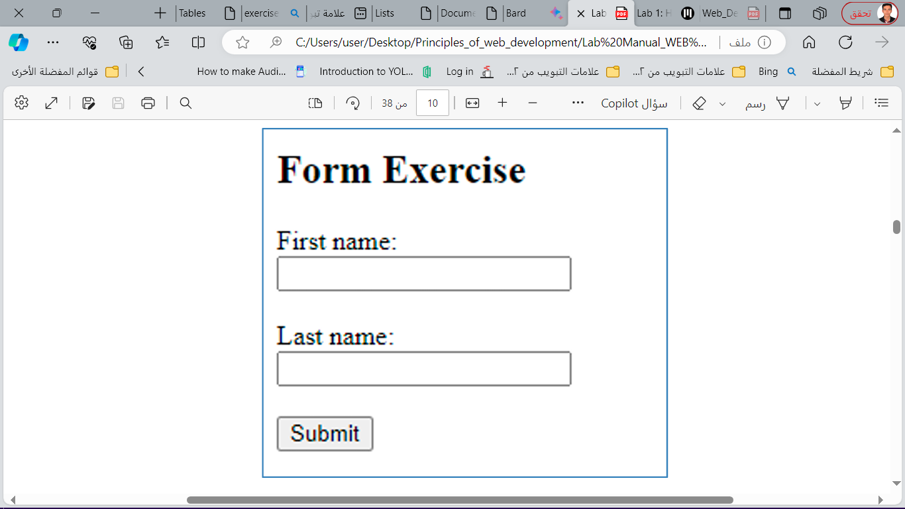Write HTML code to create the following webpage:

Code

<!DOCTYPE html>

<html>

<body>

<h2>Form Exercise</h2>

<form>

<label for="fname">First name:</label><br />

<input type="text" name="fname"><br /><br />

<label for="lname">Last name:</label><br />

<input type="text" name="lname"><br /><br />

<input type="submit" value="Submit">

</form>

</body>

</html>

* 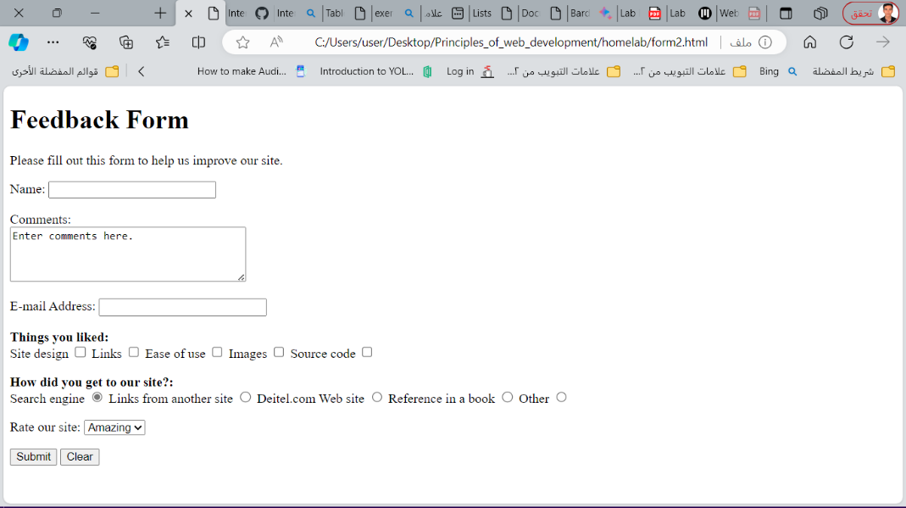Write HTML code to create the following webpage :

Code

<!DOCTYPE html>

<html>

   <head>

      <meta charset = "utf-8">

      <title>More Forms</title>

   </head>

   <body>

      <h1>Feedback Form</h1>

      <p>Please fill out this form to helpus improve our site.</p>

      <form method = "post" action = "http://www.deitel.com">

         <input type = "hidden" name = "recipient"

            value = "deitel@deitel.com">

         <input type = "hidden" name = "subject"

            value = "Feedback Form">

         <input type = "hidden" name = "redirect"

            value = "main.html">

         <p><label>Name:

               <input name = "name" type = "text" size = "25">

            </label></p>

*<!-- <textarea> creates a multiline textbox -->*

         <p><label>Comments:<br>

            <textarea name = "comments"

               rows = "4" cols = "36">Enter comments here.</textarea>

         </label></p>

*<!-- <input type = "password"> inserts a -->*

*<!-- textbox whose display is masked with -->*

*<!-- asterisk characters -->*

         <p><label>E-mail Address:

            <input name = "email" type = "password"  size = "25">

         </label></p>

         <p>

            <strong>Things you liked:</strong><br>

            <label>Site design

               <input name = "thingsliked" type = "checkbox"

                  value = "Design"></label>

            <label>Links

               <input name = "thingsliked" type = "checkbox"

                  value = "Links"></label>

            <label>Ease of use

               <input name = "thingsliked" type = "checkbox"

                  value = "Ease"></label>

            <label>Images

               <input name = "thingsliked" type = "checkbox"

                  value = "Images"></label>

            <label>Source code

               <input name = "thingsliked" type = "checkbox"

                  value = "Code"></label></p>

*<!-- <input type = "radio"> creates a radio -->*

*<!-- button. The difference between radio buttons -->*

*<!-- and checkboxes is that only one radio button -->*

*<!-- in a group can be selected. -->*

         <p><strong>How did you get to our site?:</strong><br>

            <label>Search engine

               <input name = "howtosite" type = "radio"

                  value = "search engine" checked></label>

            <label>Links from another site

               <input name = "howtosite" type = "radio"

                  value = "link"></label>

            <label>Deitel.com Web site

               <input name = "howtosite" type = "radio"

                  value = "deitel.com"></label>

            <label>Reference in a book

               <input name = "howtosite" type = "radio"

                  value = "book"></label>

            <label>Other<input name = "howtosite" type = "radio"

                  value = "other"></label></p><p>

            <label>Rate our site:

*<!-- the <select> tag presents a drop-down -->*

*<!-- list with choices indicated by the -->*

*<!-- <option> tags -->*

               <select name = "rating">

                  <option selected>Amazing</option>

                  <option>10</option>

                  <option>9</option>

                  <option>8</option>

                  <option>7</option>

                  <option>6</option>

                  <option>5</option>

                  <option>4</option>

                  <option>3</option>

                  <option>2</option>

                  <option>1</option>

                  <option>Awful</option>

               </select>

            </label>

         </p><p>

            <input type = "submit" value = "Submit">

            <input type = "reset" value = "Clear">

         </p>

      </form>

   </body>

</html>